HOME PAGE BANNER:
We sincerely apologize for an error in our July and August 2026 bills. We have corrected the affected charges. Late fees have been suspended while we complete these adjustments, and payment plans are available. Learn more →
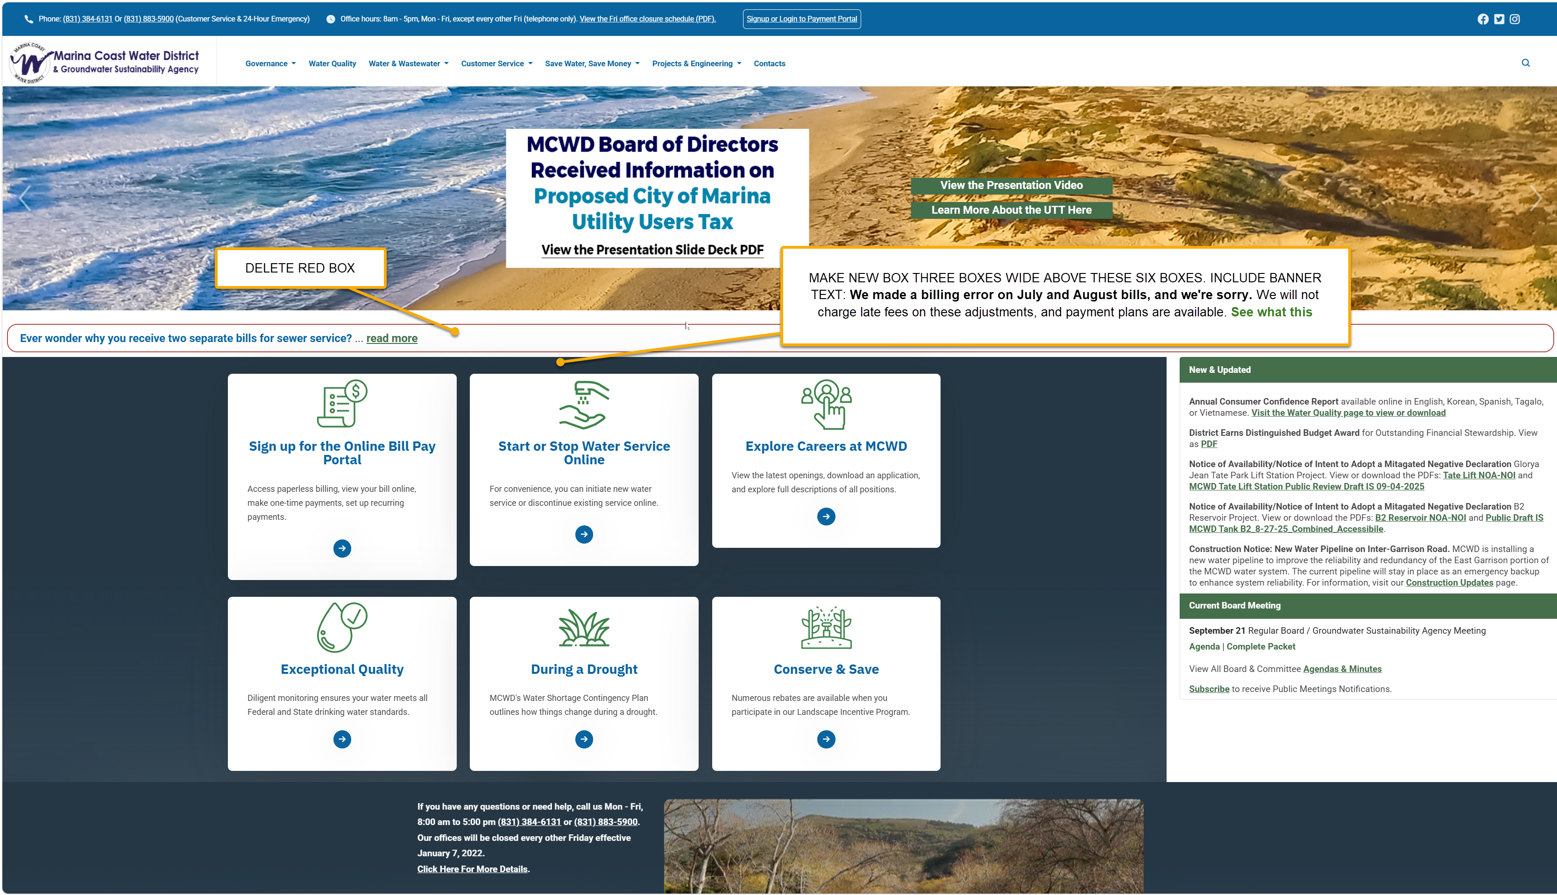

THIS GOES AT THE TOP OF THIS PAGE ABOVE ALL ELSE:
Billing Adjustment for July and August 2026
We sincerely apologize for an error in our July and August 2026 bills. The approved rates effective July 1, 2026, were not applied correctly, resulting in undercharges on affected accounts.
We have corrected the discrepancy in the system and recalculated the affected charges.
The adjustment will appear on your October billing statement and covers only the difference between the original charges and the charges under the approved rates. The summary included with your letter shows the original charges, corrected charges, and total adjustment for your account. You may receive your October bill before your letter arrives.
We understand that an unexpected adjustment can be frustrating, and we sincerely apologize for the inconvenience. Late fees have been suspended while the District completes these billing adjustments. If you are experiencing financial hardship and need assistance, please do not hesitate to contact us. Payment plans are available, and we are here to help.
If you have questions or need help
If you have questions or would like help reviewing your adjustment summary, please contact our Customer Service team.
- By phone at (831) 384-6131 or (831) 883-5900
- By email at customerservice@mcwd.org
- Office hours: Monday through Friday, 8:00 a.m. to 5:00 p.m.
We take responsibility for this error and appreciate your patience as we correct it.

We sincerely apologize for an error in our July and August 2026 bills. The approved rates effective July 1, 2026, were not applied correctly, resulting in undercharges on affected accounts.
We have corrected the discrepancy in the system and recalculated the affected charges.
The adjustment will appear on your October billing statement and covers only the difference between the original charges and the charges under the approved rates. The summary included with your letter shows the original charges, corrected charges, and total adjustment for your account.
We understand that an unexpected adjustment can be frustrating, and we sincerely apologize for the inconvenience. Late fees have been suspended while the District completes these billing adjustments. Payment plans are available upon request.
If you have questions or need assistance
If you are experiencing financial hardship and need assistance, or would like help reviewing your adjustment summary, please contact us. We are here to help.
- By phone at (831) 384-6131 or (831) 883-5900
- Or email customerservice@mcwd.org.
- Office Hours: Monday through Friday, 8:00 a.m. to 5:00 p.m.
We take responsibility for this error and appreciate your patience as we correct it.

July and 60% of august billing for all customers had old rates rather than the new rates
Spent September figuring it out.
Sent a letter to all 11,500 accounts affected (get letter). The Letter was kind of heavy – and an FAQ, then an apology in one line. Sounded cold. Half of the letters went out. The rest were stopped. Mary rewrote it a little simpler and warmer – it will take two weeks for those to print and mail. In the meantime, people are receiving their updated bills.
The average adjustment is $6.50 per month for sewer and water. It is a two-month bill, so the average is $13.
If you have questions, please contact customer service,
If you have questions or need assistance
We understand that unexpected account adjustments can be concerning. Our Customer Service team is available to answer questions and discuss payment options.

- By phone at (831) 384-6131 or (831) 883-5900
- Or email customerservice@mcwd.org.
- Office Hours: Monday through Friday, 8:00 a.m. to 5:00 p.m.
Our customer team is here to help. If you have difficulty paying, we can help by not charging late fees, working out a payment plan, etc.
A director (Williams) is upset and pressing management on this.
DELIVERABLES:
Banner on homepage that leads to inside page
Explanation at top of ways to pay your bill page: Ways to Pay Your Water Bill | Marina Coast Water District

JEAN: LET’S TALK: FOG: Fog inspection – let them know of a new fee in March. Mary says the charge should not be a big deal on eblast or at all.

